An Investigation of the Effect of fused deposition modelling process parameters on mechanical properties of thermoplastics

Andrei Danut Mazurchevici, Dumitru Nedelcu* & Ramona Popa

a Gheorghe Asachi, Technical University of Iasi, Blvd Mangeron No. 59A, 700050, Iasi, Romania

**Abstract-** Fusion Modeling is a subset of additive manufacturing (AM) that uses Computer-Aided Design (CAD) files to create a product. AD is widely used for prototype and low-volume production because of its durability, cost-effectiveness, safe and efficient operation, and ability to manage high-quality thermoplastics. Given its potential to facilitate the construction of functional components with complicated geometry, fused deposition modelling (FDM) has emerged as a viable AM technique offering an alternative to traditional fabrication methods. It is possible to control the mechanical qualities of a manufactured product by adjusting many process factors. This research aims to understand better how a desktop 3D printer's build orientation, layer thickness, and fibre volume content affect the mechanical performance of continuous fiber-reinforced composites. The mechanical response of the printed specimens is measured by performing tensile and three-point bending tests. Broken surfaces captured by a scanning electron microscope (SEM) are analyzed to ascertain process factors' role in the emergence of failure modes. Then the genetic algorithm is used to optimize all the mechanical tests to obtain optimal principal stress, deformation, sheer stress, and elastic stress values. In most situations, the findings reveal that strength and stiffness improve with a rise in fibre volume content, although the amount of improvement in mechanical performance does not.

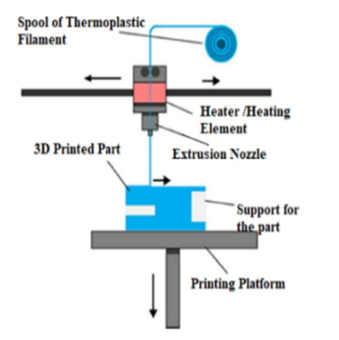**Keywords:** AM (Additive Manufacturing), 3D Printing, Mechanical Properties, Overhang angles, Mechanical testing.

# Introduction

AM utilizes CAD data to build products layer by layer. In contrast to typical manufacturing processes, AM builds three-dimensional items by layering material. This enables AM to print complicated, artificial components faster and cheaply. AM manufacturing is faster and more effective because 3D printing doesn't require special tools, leaves little wastage, can print complex frameworks at high density, and allows product customization and flexibility. AM technique FDM is common. Scott Crump, Stratasys' co-founder, invented the FDM process in 1989. FDM uses thermoplastic filament to layer-print the component. AM can layer-by-layer construct an object from a CAD file. Layering raw materials makes 3D goods cheaper and quicker than conventional production. Inkjet modelling (IJM), selective laser sintering (SLS), DMD, FDM, and stereolithography are commercial AM technologies [1].

Figure 1. FDM process [2].

1. **Fused Deposition Modeling (FDM) Process**

Figure 1 illustrates the FDM process: the liquefying head warms a continuous filament of material to a semi-liquid condition, which is subsequently extruded onto the printing bed/platform. FDM uses semi-liquid thermoplastic filament materials that fuse at ambient temperature to form layer-wise layered objects [2].

Because there are many different forms of non-linear events involved, the experimental optimization of any welding operation is often a highly pricey and time-consuming effort. The genetic algorithm is one of the approaches that is being employed by a lot of people to tackle this problem. The GA is an algorithm for global optimization, and the target function does not have to be differentiable for it to work. This makes it possible to apply the method to the solution of challenging problems, such as those involving multimodal, discontinuous, or noisy networks [2].

1. **Fused Deposition Modeling (FDM) Parameters**

Figure 2 describes several FDM process parameters. These are also key factors:

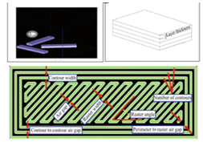

Figure 2. (a) Build orientation (b) layer thickness (c) FDM tool path parameter [3]

* The build platform's X, Y, and Z axes indicate the part's construction orientation, as shown in Figure 2a.
* The nozzle tip layer thickness is shown in Figure 2b. Layer thickness varies depending on material and tip size.
* An "air gap" arises between subsequent raster tool tracks on the same layer, as seen in Figure 2c.

# Literature of review

There is a wide range of authors who have given their findings which are given below in table 1.

Table 1 Comparison of the reviewed literature

|  |  |  |
| --- | --- | --- |
| **Authors** | **Technique used** | **Outcomes** |
| Enemuoh et al., (2021) [4] | ANOVA | The results show that the predicted hardness and tensile strength properties were adequately maximized while the energy consumption, production time, part weight, and dimensional changes were adequately minimized at the optimized control factor levels. |
| Awasthi et al., (2021) [5] | FDM | The FDM approach facilitates fast prototyping, individualized design, and extensive customization of TPEs When compared to conventional molding techniques. |
| Penumakala et al., (2020) [6] | FDM | Mechanical properties of printed objects can be estimated using analytical and numerical models that simulate the FDM printing process. |
| Bakır el al., (2020) [7] | FDM | FDM-printed rPET constructions are acceptable for load-bearing applications because optimum process parameters provide strength and modulus values comparable to injection-molded components. |
| Bahr et al., (2018) [8] | FDM | The mechanical qualities of a road are significantly impacted by the sintering phenomena and crystallization at the contact. |
| Bhalodi et al., (2018) [9] | FDM | There is now a stronger connection between neck length growth, interface temperature, and time. |
| Chacon et al., (2017) [10] | FDM | Changes in mechanical qualities as a function of layer thickness and feed rate are insignificant, particularly for the on and flat orientations when the layer thickness is low. |
| Ning et al., (2017) [11] | FDM | Consequently, a fused deposition modeling machine is used to create carbon fiber-reinforced plastic composite components. To determine the tensile qualities, tensile tests are performed. |

# Background Study

FFF layers of thermoplastic material using a nozzle. Complex forms can't be created using current methods. Engineering materials outlast thermoplastics. FFF composite 3D printing feedstock employing carbon fibres in a thermoplastic matrix for strength and stiffness are investigated in this study. Mark with mechanical qualities similar to unidirectional epoxy matrix composites, one printing of continuous carbon fibres surpasses unreinforced thermoplastics. Brittle continuous carbon fibres restrict design freedom. Short carbon microfiber filaments (~100 μm) print better than thermoplastic and may be used in traditional printing processes. FFF design freedom may be maintained with short fibre filaments with longer strands that have mechanical qualities similar to continuous fibre composites.

# Problem Formulation

FDM melts thermoplastic and extrudes it via a nozzle to make a three-dimensional object. Thermoplastic conditions enhance the component. To determine how FDM process factors affect component attributes to extend component life to explain the relationship between process parameter variable operating points and mechanical performance. The mathematical functions used to describe the goal, in this case, could be regarded to evolve as the geometry of the various components is modified. As this is a multi-modal issue, GA can be used to solve it instead of the more traditional gradient-based optimization methods. Experimentally verifying optimization results on test components reveals this study's goal.

# Research objective

* To reduce condensation before testing like the produced specimens.
* To better understand how process factors affect mechanical performance and clarify the results.
* Test specimens are created at two temperatures to determine how temperature influences test findings.

# Research Methodology

Figure 3 shows the workflow of the methodology and

contains various steps of ABS-PLA Fabrication.

ABS-PLA Fabrication

Test requirement and specification

Selection of process parameters

* Tensile test
* Compressive test
* Bending test
* Hardness test
* Extrusion rate
* Printing speed
* Layer thickness
* Temperature

Figure 3: Proposed methodology.

# ABS-PLA Fabrication

FDM is performed by using The APIUM P220 series FDM printer can print ABS-PLA, Polybenzimidazole (PBI), American Petroleum Institute (API), and Thermoplastic Polyimide (TPI) plastics, as well as severe temperature and technical plastics. Figure 4 depicts a Apium P220 Series FDM printer.

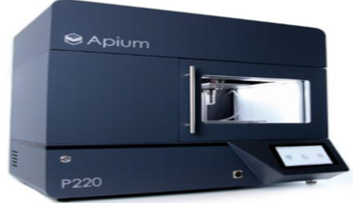

Figure 4. Apium P220 Series FDM printer [12]

Table 2 shows Polylactic Acid (PLA) and Acrylonitrile Butadiene Styrene (ABS), two plastics with distinct properties. Carbon fibre surrounds the ABS-PLA composite in this composition. [13]

Table 2. Material properties of PLA and ABD [14]

|  |  |  |  |  |
| --- | --- | --- | --- | --- |
| Properties | Units | ASTM | Common material  (PLA and ABS) | |
| Modulus of elasticity | MPa | D 638-04 | 3750 | 2600-3000 |
| Elongation at Break | % | D 638-05 | **7** | 50 |
| Load impact strength | J/m | D 256-06 | 26 | 34 |
| Color | - | - | Various | Various |
| Density | Kg/mm3 | **-** | 0.00105 | 0.00125 |
| Tensile  Strength | MPa | D 638-03 | 59 | 40 |

# Test Requirements specifications

Tensile and compressive tests are popular mechanical testing procedures for material functioning. Researching tensile and compressive mechanical behavior yields material acreage data for element drawing and execution evaluations.

# Tensile test

Specimen dimensions: narrow width 9.53 mm, thick length 6.35 mm, fillet radius 12.7 mm, overall width 3.40 mm. Figure 5 shows tensile test results.

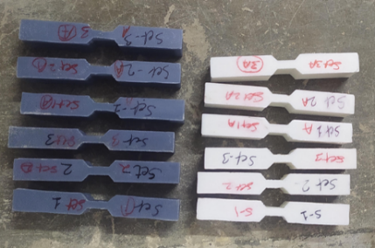

Figure 5. Tensile test specimen and sizes. [15]

Figure 6 shows a tensile tester. Displays sample structure and components. Tensile testing uses a 5mm/min crosshead speed regardless of material or application.

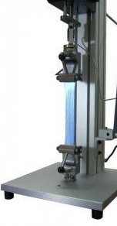

Figure 6. Tensile testing machine [16]

# Compressive test

Figure 7 compressive strength testing apparatus featured a crossheading speed of 1.3mm/min and a stack range of 50 KN.

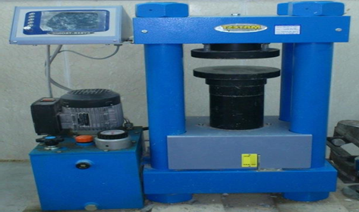

Figure 7. Compressive strength testing machine [17]

Figure 8 suggests a fixture holding the compression sample and compressive specimen. Prevents buckling and produces pure compression.

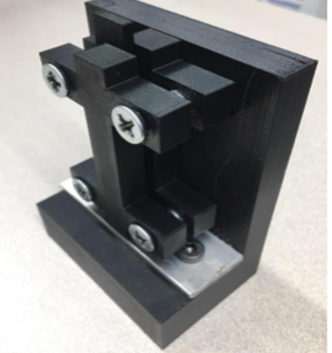

Figure 8: Compression test fixture [15]

# Number of samples

Three examples test ABS-PLA criteria and pricing. ASTM standards need five isotropic samples. However, research shows that three specimens, not five, are usually adequate for meaningful conclusions. Each experiment uses created specimens.

# Speed of testing

# If test features move at 5 mm/min, stiffness testing will be problematic. Compression testing manipulates test matches at this pace.

# Hardness Test

Brass, bronze, aluminum, and gold may be tested for Brinell’s hardness. PLA was tougher and stiffer than ABS in Brinell hardness tests (Figure 9). Brinell hardness testers cannot be used on particularly hard or sensitive materials. The Brinell hardness number (BHN) test presses a steel ball of a thickness (F) against the test material's surface (F). After removing the weight, measure the indentation's average diameter (d) (P). BHN is computed by dividing the applied force P (in kilograms) by the indentation's spherical surface area A. [18]

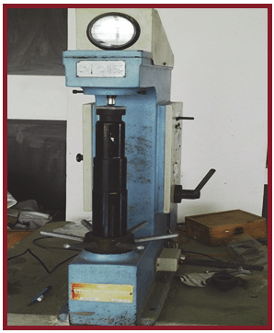

Figure 9. Brinell hardness testing machine [19]

Since the deformations caused by an indenter are similar to those seen in a tension test at ultimate tensile strength, many empirical connections between metals and alloys' hardness and engineering's ultimate tensile strength have been found. The bending test specimen is shown in Figure 10.

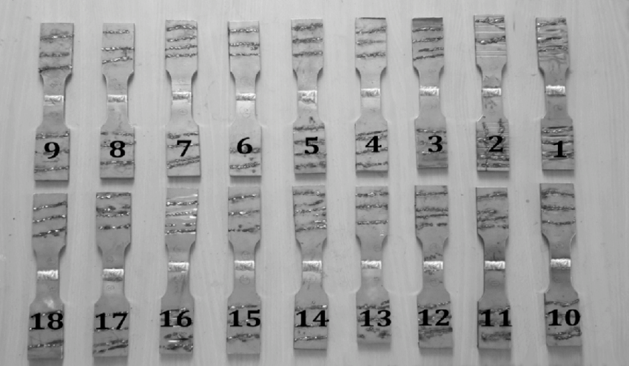

Figure 10. Hardness test specimens [20]

# Flexible Strength

Flexural strength is a material's capacity to bend. Soft-flexible PLA's 92A shore hardness makes it flexible, unlike ordinary PLA, which is brittle. Due to their toughness, abs fibres can sustain much.[21]

# Selection of Process Parameters

Various parameters are selected for evaluation which are given as follows:

* Layer thickness
* Temperature effect
* Surface roughness

# Optimization of the mechanical test using GA.

Finally, the tensile test, compressive test, bending test, and hardness test are optimized by using the GA technique. To optimize the results obtained from stress and strain analysis from Ansys, a fitness function consisting of dependent variables such as principal stress, principal elastic stress, sheer stress, and deformation is designed and simulated with the help of Matlab.

The functions are interdependent upon similar parameters which are the main controlling factor for analysis during tensile, compressive, impact, and bending tests which are described below:

1. **For Bending test**

* **Maximum principal stress ()**

(1)

Where, Peak current, back current, pulse rate, and pulse width are written as (x 1), (x 2), (x 3), and (x 4) respectively.

* **Maximum principal Elastic Strain ()**

(2)

* **Shear stress ()**

(3)

* **Total deformation ()**

(4)

1. **For Compression test**

* **Principal stress ()**

(5)

* **Maximum Principal Elastic Strain ()**

(6)

* **Shear stress ()**

(7)

* **Total deformation ()**

(8)

1. **For hardness test**

* **Principal stress ()**

= -93.3 - 7.4* + 11.13* + 1.4*- 4.23* - 0.124*(^2) - 0.857*(*) - 2.342*(*) + 1.12*(*) + 0.342*(*) - 0.238*(*); (9)

* **Maximum Principal Elastic Strain ()**

(10)

* **Shear stress ()**

(11)

* **Total deformation ()**

(12)

1. **For tensile test**

* **Maximum principal stress ()**

(13)

* **Maximum Principal Elastic Strain ()**

(14)

* **Shear stress ()**

(15)

* **Total deformation ()**

(16)

# Results

# Studying how processing factors impact mechanical attributes is crucial. Build orientation, extruder temperature, raster angle, layer height, infill percentage, and pattern affect the mechanical qualities of FDM-manufactured parts.

# Parameters for both materials (PLA and ABS)

Tables 1 and 2 demonstrate PLA and ABS material analysis parameters and circumstances for physical and mechanical qualities Table 3 and 4 shows the parameters and condition for materials respectively.

Table 3: Parameters used for materials.

|  |  |  |  |  |  |  |  |
| --- | --- | --- | --- | --- | --- | --- | --- |
| Sample | Specified Tests | Laboratory Results | | | | | |
| 1 | 2 | 3 | 1A | 2A | 3A |
| Polymer: PLA Specimen Process Fusion Deposition Modeling On 3D Printer | Tensile strength | 15.05 N/mm2 | 22.28 N/mm2 | 27.85 N/mm2 | 26.49 N/mm2 | 24.07 N/mm2 | 22.88 N/mm2 |
| Compressive Strength | 84.47 N/mm2 | 37.82 N/mm2 | 19.16 N/mm2 | 96.02 N/mm2 | 81.28 N/mm2 | 57.64 N/mm² |
| Bending Strength | 0.49 N/mm‑2 | 0.57 N/mm2 | 0.81 N/mm2 | 0.68 N/mm2 | 0.62 N/mm2 | 0.58 N/mm2 |
| Hardness Test Rockwell Hardness | 47 HRC | 57 HRC | 82 HRC | 60 HRC | 52 HRC | 43 HRC |

Table 4: Condition used for materials.

|  |  |  |  |  |  |  |  |
| --- | --- | --- | --- | --- | --- | --- | --- |
| Sample | Specified Tests | Laboratory Results | | | | | |
| 1 | 2 | 3 | 1A | 2A | 3A |
| Polymer: ABS Specimen Process Fusion Deposition Modelling On 3D Printer | Tensile strength | 22.28  N/mm2 | 28.06 N/mm2 | 37.33 N/mm2 | 27.10 N/mm2 | 18.43 N/mm2 | 12.64 N/mm2 |
| Compressive Strength | 48.53 N/mm2 | 20.12 N/mm2 | 10.08 N/mm2 | 62.68 N/mm2 | 38.26 N/mm2 | 18.69 N/mm² |
| Bending Strength | 0.80 N/mm‑2 | 0.85 N/mm2 | 0.88 N/mm2 | 0.73 N/mm2 | 0.65 N/mm2 | 0.58 N/mm2 |
| Hardness Test Rockwell Hardness | 8 HRC | 13 HRC | 38 HRC | 104 HRC | 98 HRC | 85 HRC |

# Fusion Modeling of PLA and ABS

# Based on Tensile Strength

A directional deformation coordinate system was created to predict the deformation direction. the highest principal stress, which matches ANSYS's main stress 1. The equivalent strain, which ignores hydrostatic stressing energy stored in a deformed body, is a shear strain measurement in the material. After an external force is removed, everything returns to normal. The total deformation shows all model distortions' X, Y, and Z-axis. Figure 11 shows the tensile strength properties of PLA and ABS fusion.

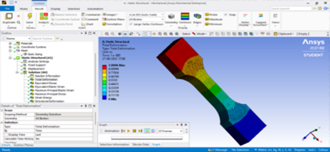

Figure 11: Shows the tensile strength properties of PLA and ABS fusion.

# Based on Compression Testing

Stress and strain determine an object's interior strain energy. This model's deformation findings, including the equivalent stress of elasticity, maximum primary stress, the meshing technique for continuous geometry, shear stress, and total deformation, may be shown in three dimensions using the complete deformation option (X, Y, and Z). Figure 12 Shows the Compression Testing properties of PLA and ABS fusion.

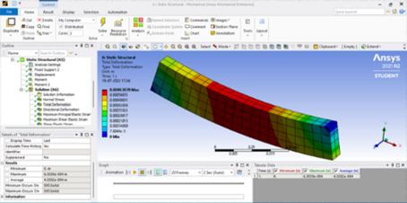

Figure 12: Shows the Compression Testing properties of PLA and ABS fusion.

# Based on the bending test

This examination standardized data collecting for R&D, specification validation, and quality control. Normal force, P, bends a beam or frame. The beam cannot recover after bending. Maximum elastic strain—the stress at which a material undergoes irreversible deformation—is connected to equivalent stress, the initial analysis setup (the analysis model's starting variables), the maximize elastic principle (elasticity is a deformable body's capacity), and the analysis model. Shear stress may not be largest along the neutral axis, the structure's maximum deformation, in the model-FG porous SMA/pyroclastic composite cantilever beam bending model. Figure 13 shows the bending test properties of PLA and ABS fusion.

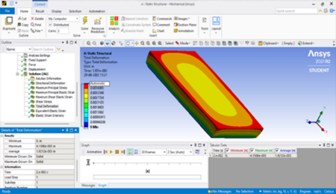

Figure 13: Shows the bending test properties of PLA and ABS fusion.

# Based on the hardness test

To perform the hardening test 8 samples are taken and each sample is tested 3 times and their harness values are recorded. Then from these 3 tested values of each sample, an average hardness value is calculated as shown in the table given in figure 14.

|  |  |  |  |  |
| --- | --- | --- | --- | --- |
| Sample number | Hardness (Rock well) | | | Average hardness (Rockwell) |
| Test 1 | Test 2 | Test 3 |
| 1 | 43.0 | 44.3 | 42.3 | 43.20 |
| 2 | 37.2 | 35.6 | 42.5 | 38.43 |
| 3 | 63.3 | 61.0 | 61.4 | 61.90 |
| 4 | 56.0 | 53.4 | 54.8 | 54.73 |
| 5 | 63.7 | 62.9 | 62.9 | 63.17 |
| 6 | 54.2 | 55.7 | 59.9 | 56.60 |
| 7 | 61.3 | 61.7 | 63.7 | 62.23 |
| 8 | 52.5 | 52.4 | 49.8 | 51.57 |

Figure 14. Hardness test

# Based on stress-strain and load and deformation for PLA material

Figure 17 illustrates the graphical representation between load or applied force (in KN) and deformation (in mm) along with stress (in MPa) and strain (in mm) curves for samples of PLA material. It could be seen from figure 15 (A) that a large amount of applied force would result in a very small amount of deformation and the curve shown in Figure 15 (B) depicts the relationship between stress and strain.

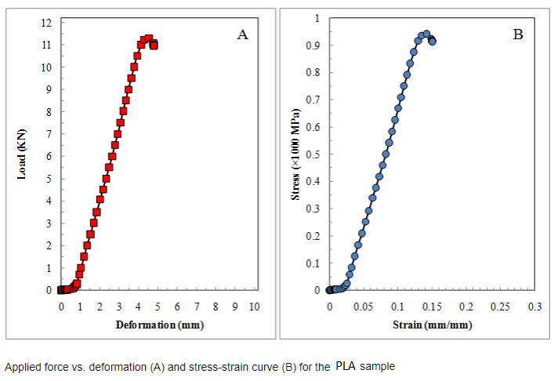

Figure 15. Applied force vs. deformation (A) and stress-strain curve (B) for the PLA sample.

# Based on stress-strain and load and deformation for ABS material

Figure 16 shows the graphical representation between load or applied force (in KN) and deformation (in mm) along with stress (in MPa) and strain (in mm) curves for samples of ABS material. It could be seen from Figure 15 (A) that a large amount of applied force would result in a very small amount of deformation and the curve shown in Figure 14 (B) depicts the relationship between stress and strain for ABS material.

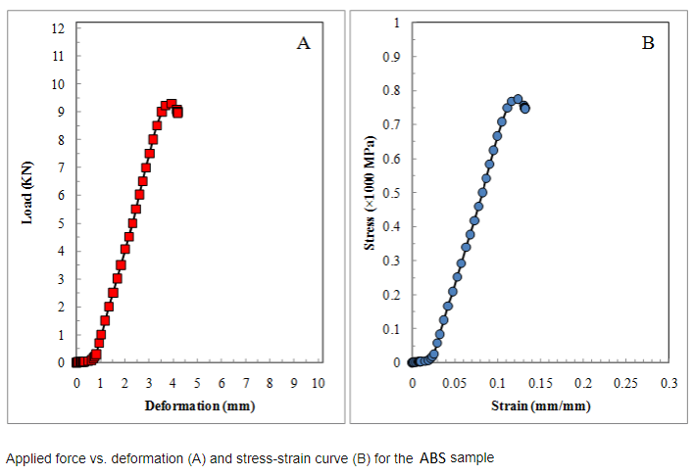

Figure 16 Applied force vs. deformation (A) and stress-strain curve (B) for the PLA sample.

# Based on stress-strain

Even after achieving maximal plastic deformation, stress and strain continue to vary in the bilinear dynamical hardening process. However, the apparent form shift is difficult to spot. The curve shown in Figure 17 depicts the relationship between stress and strain. The image shows that stress suddenly rises with strain.

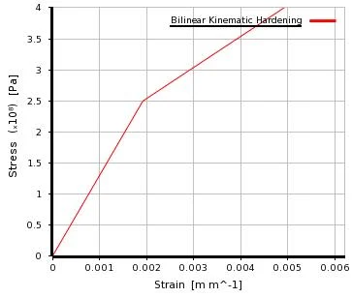

Figure 17. Stress-Strain relationship graph

# Based on simulation

Force convergence is the internal forces in each step. Figure 18 shows the graphical representation of the convergence plot between force (N) concerning time (in a sec) of simulation results.

# 

Figure 18. Force Convergence plot

# Comparison Graphs of PLA and ABS

# F-Punch (the resulting change in momentum is proportional to its impulse).

# U-Punch Specimen (one atomic layer determines strength and ductility).

# Based on Tensile Strength

Figure 19 depicts a trade-off between Stress (MPa) and Strain (mm) where PLA F and ABS F perform better than PLA U and ABS U. This depiction measures material tensile by parameters.

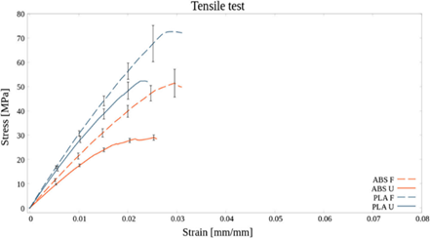

Figure 19: Tensile Strength comparison graph

# Based on Compression Testing

Figure 22 demonstrates a trade-off between stress (in MPa) and strain (in mm) where PLA F and ABS F outperform PLA U and ABS U. This model measures compression by parameters for each material.

Figure 20: Comparison testing comparison graph.

# Based on the bending test

Figure 21 depicts a trade-off between Force (N) and Displacement (mm), with PLA F and ABS F outperforming PLA U and ABS U. This depiction is used to quantify material bending.

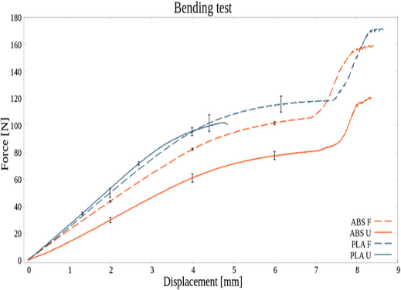

Figure 21: Bending test comparison graph.

# Conclusion and Future Scope

This study describes the factors that affect the precision, smoothness, and polish of FDM components, including the process characteristics used. Scholars employ AM methodologies and statistical optimization tools to discover which FDM process elements most affect a goal output, which parameters are crucial, and which parameters should be combined most efficiently. FDM process factors affect component quality and effectiveness, making this study crucial. FDM thermoplastics PLA and ABS are mainly explored. Build orientation, layer thickness, and fiber volume composition affected desktop 3D-printed continuous fiber-reinforced composite mechanical performance. Tensile and three-point bending tests evaluate printed specimen mechanics. According to the research, fiber volume content enhances strength and stiffness but not mechanical performance. FDM-printed CFRCs are immature. Vertical layer adhesion needs research. Only ABS, PLA, and nylon are low-temperature thermoplastics. Investigate impregnating high-temperature polymers over liquefier reinforcements. Two-nozzle printing polymers and reinforcements need tweaking. The GA optimization technique is used to optimize various tests, including tensile, compressive, bending, and hardness tests. Fitness functions such as principal stress, principal elastic stress, shear stress, and deformation are calculated and optimized for all tests. For the bending test, the optimized values of principal stress, principal elastic stress, shear stress, and deformation are 107.55, 108.345, 13.451, and 24.122 respectively. For the compression test, the optimized values are 70.322, 49.145, 4.567, and 4.342 respectively. For the hardness test, the optimized values are 11.284, 121.323, 8.463, and 8.947 respectively. Finally, for the tensile test, the optimized values are 78.56, 0.354, 4.744, and 1.789 respectively. In future work, the integration of machine learning techniques with GAs can improve the accuracy of predictive models for mechanical properties. By using GA to identify the most important process parameters that affect mechanical properties, and then using machine learning to build a predictive model that can accurately predict the mechanical properties based on those parameters.

# References

1. Mohamed, Omar A., Syed H. Masood, and Jahar L. Bhowmik. "Optimization of fused deposition modeling process parameters: a review of current research and prospects." Advances in manufacturing 3, no. 1 (2015): 42-53.
2. Mohamed, Omar Ahmed, Syed Hasan Masood, and Jahar Lal Bhowmik. "Optimization of fused deposition modeling process parameters for dimensional accuracy using I-optimality criterion." Measurement 81 (2016): 174-196.
3. Sheoran, Ankita Jaisingh, and Harish Kumar. "Fused Deposition modeling process parameters optimization and effect on mechanical properties and part quality: Review and reflection on present research." Materials Today: Proceedings 21 (2020): 1659-1672.
4. Mohamed, Omar A., Syed H. Masood, and Jahar L. Bhowmik. "Optimization of fused deposition modeling process parameters: a review of current research and prospects." Advances in manufacturing 3, no. 1 (2015): 42-53.
5. Enemuoh, Emmanuel U., Stefan Duginski, Connor Feyen, and Venkata G. Menta. "Effect of process parameters on energy consumption, physical, and mechanical properties of fused deposition modeling." Polymers 13, no. 15 (2021): 2406.
6. Awasthi, Pratiksha, and Shib Shankar Banerjee. "Fused deposition modeling of thermoplastic elastomeric materials: Challenges and opportunities." Additive Manufacturing 46 (2021): 102177.
7. Penumakala, Pavan Kumar, Jose Santo, and Alen Thomas. "A critical review on the fused deposition modeling of thermoplastic polymer composites." Composites Part B: Engineering 201 (2020): 108336.
8. Bakır, Ali Alperen, Resul Atik, and Sezer Özerinç. "Effect of fused deposition modeling process parameters on the mechanical properties of recycled polyethylene terephthalate parts." Journal of Applied Polymer Science 138, no. 3 (2021): 49709.
9. Bähr, Friedrich, and Engelbert Westkämper. "Correlations between influencing parameters and quality properties of components produced by fused deposition modeling." Procedia Cirp 72 (2018): 1214-1219.
10. Bhalodi, Deep, Karan Zalavadiya, and Pavan Kumar Gurrala. "Influence of temperature on polymer parts manufactured by fused deposition modeling process." Journal of the Brazilian Society of Mechanical Sciences and Engineering 41, no. 3 (2019): 1-11.
11. Chacón, J. M., Miguel Angel Caminero, Eustaquio García-Plaza, and Pedro J. Núnez. "Additive manufacturing of PLA structures using fused deposition modelling: Effect of process parameters on mechanical properties and their optimal selection." Materials & Design 124 (2017): 143-157.
12. Ning, Fuda, Weilong Cong, Yingbin Hu, and Hui Wang. "Additive manufacturing of carbon fiber-reinforced plastic composites using fused deposition modeling: Effects of process parameters on tensile properties." Journal of composite materials 51, no. 4 (2017): 451-462.
13. Oosthuizen, Gert Adriaan, D. Hagedorn-Hansen, and T. Gerhold. "Evaluation of rapid product development technologies for the production of the prosthesis in developing communities." Proceedings of SAIIE 25 (2013).
14. Song, Yichi, et al. "Measurements of the mechanical response of unidirectional 3D-printed PLA." Materials and design 123 (2017): 154-164
15. Oosthuizen, Gert Adriaan, D. Hagedorn-Hansen, and T. Gerhold. "Evaluation of rapid product development technologies for the production of the prosthesis in developing communities." Proceedings of SAIIE 25 (2013).
16. <https://www.testresources.net/applications/test-types/tensile-test/thermoplastic-thermoset-plastics-tensile-testing/>
17. DAWOOD, Eethar Thanon, and Ali Jihad HAMAD. "Effect of NaCl on the Mechanical Properties of Structural Lightweight Concrete Reinforced with Fibers." Walailak Journal of Science and Technology (WJST) 14, no. 5 (2017): 389-399.
18. [https://markforged.com/resources/blog/pla-abs-nylon access on 21/06/2021](https://markforged.com/resources/blog/pla-abs-nylon%20access%20on%2021/06/2021)
19. Patil, Chetan, Hemant Patil, and Hiralal Patil. "Experimental investigation of the hardness of FSW and TIG joints of Aluminium alloys of AA7075 and AA6061." Frattura ed Integrità Strutturale 10, no. 37 (2016): 325-332.
20. Sharma, Neeraj, Wathiq Sleam Abduallah, Manish Garg, Rahul Dev Gupta, Rajesh Khanna, and Rakesh Chandmal Sharma. "Optimization of tig welding parameters for the 202 stainless steel using NSGA-II." Journal of Engineering Research 8, no. 4 (2020).
21. https://www.allthat3d.com/pla-vs-abs/ access on 21/06/2021.